**Exercise_No:11**

**Date:23-11-2020**

**Aim:**

**To print the GCD for the given two number using recursion.**

**Program:**

**def gcd(a, b):**

**if(b==0):**

**return a**

**else:**

**return gcd(b,a%b)**

**a=int(input("Enter first number:"))**

**b=int(input("Enter second number:"))**

**GCD=gcd(a,b)**

**print ("GCD is:")**

**print (GCD)**

**Link:**

[**http://103.53.53.18/mod/vpl/forms/submissionview.php?id=326&userid=1684#**](http://103.53.53.18/mod/vpl/forms/submissionview.php?id=326&userid=1684#)

**output:**

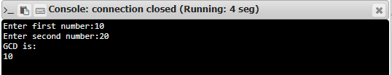

**Result:**

**Thus, the output for the program is successfully printed.**